## GUI Graphical User Interfaces

### Home Page

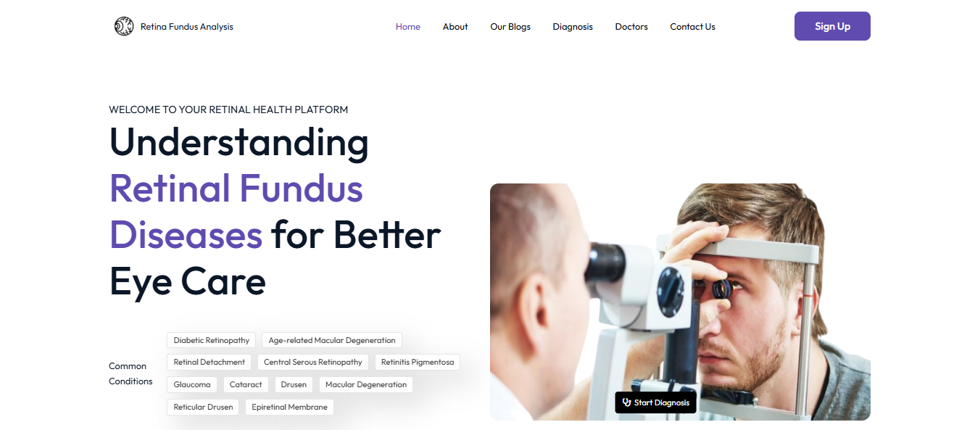

The home page of the Retina Fundus Analysis Platform welcomes users with a clean interface, listing common retinal conditions like AMD and Glaucoma for easy navigation. It features a patient eye examination image, emphasizing the system’s focus on AI-driven retinal disease diagnosis.

* + 1. About Page :

Section 1:

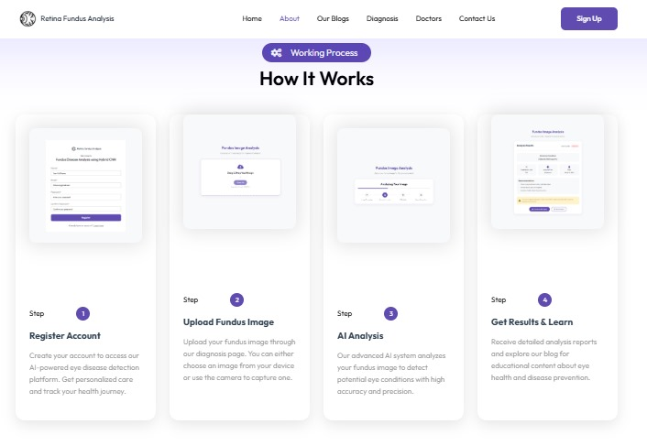

The "About" page of the Retina Fundus Analysis platform outlines the step-by-step working process for users to register, upload fundus images, and receive AI-driven analysis. It highlights the system’s accuracy in detecting eye conditions and provides educational content on eye health and disease prevention.

Section 2:

The "About" page Section 2 of the Retina Fundus Analysis platform invites healthcare professionals to join a network of eye care specialists. It highlights benefits like expanding practice reach, efficient appointment management, and enhanced patient care through AI technology.

* + 1. Blog :

Section 1 :

The "Blog Section 1" of the Retina Fundus Analysis platform offers in-depth articles on fundus disease detection and management, featuring a searchable category filter. It highlights recommended blogs like "What is Drusen?" and "Types of Drusen," updated as of December 2024, with illustrative fundus images.

Section 2:

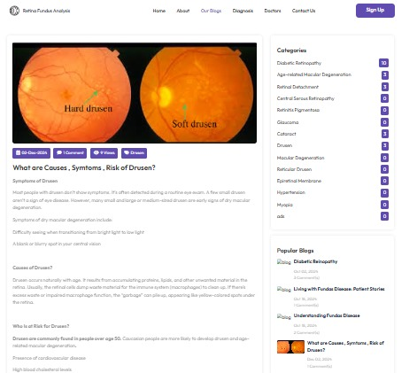

The "Blog Section 2" of the Retina Fundus Analysis platform showcases a collection of educational blog posts on eye health, featuring detailed articles with fundus images. It includes titles like "Retinal Detachment Symptoms and Causes," encouraging users to read more and stay informed about retinal conditions.

3.6.4 Dignosis :

Section 1:

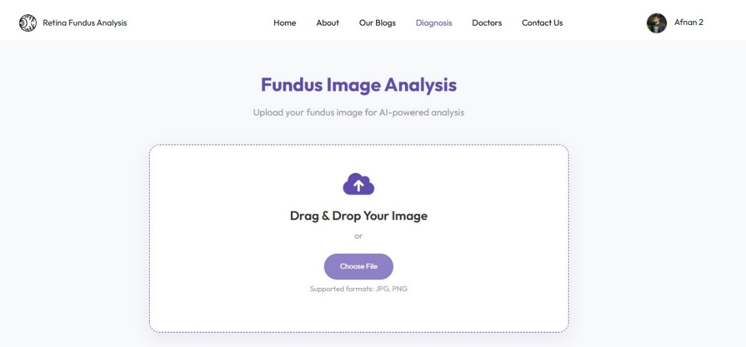

The "Diagnosis Page Section 1" of the Retina Fundus Analysis platform provides a user-friendly interface for uploading fundus images via drag-and-drop or file selection. It supports AI-powered analysis of retinal images in JPEG and PNG formats, initiating the diagnostic process.

Section 2:

The "Diagnosis Page Section 2" of the Retina Fundus Analysis platform displays the AI-powered analysis process with a progress bar, covering image processing, feature extraction, and report generation. It provides users with real-time updates as their uploaded fundus image is analyzed for potential retinal conditions.

Section 3:

The "Diagnosis Page Section 3" of the Retina Fundus Analysis platform presents the detailed diagnosis report, identifying the retinal condition as "Normal" with a confidence score of 99%. It includes options to download the report or seek a second opinion from eye care specialists for further evaluation.

* + 1. Doctor :

Setcion 1 :

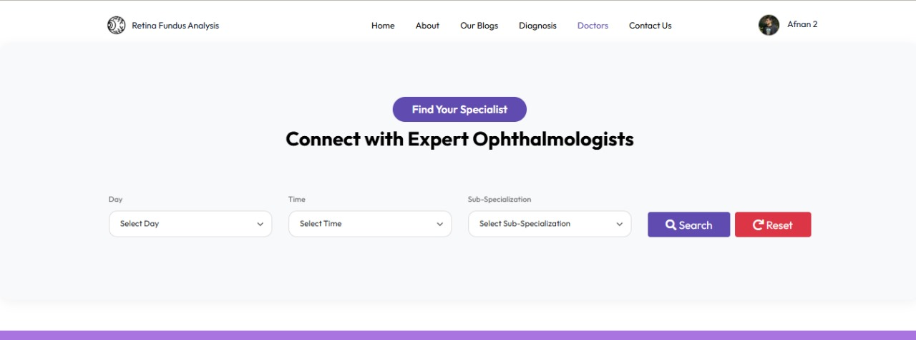

The "Doctors" page of the Retina Fundus Analysis platform lists certified eye care specialists available for consultations, featuring their photos, names, and ratings. It allows users to book appointments directly, ensuring access to expert opinions for retinal health concerns.

Section 2 (Dashboard):

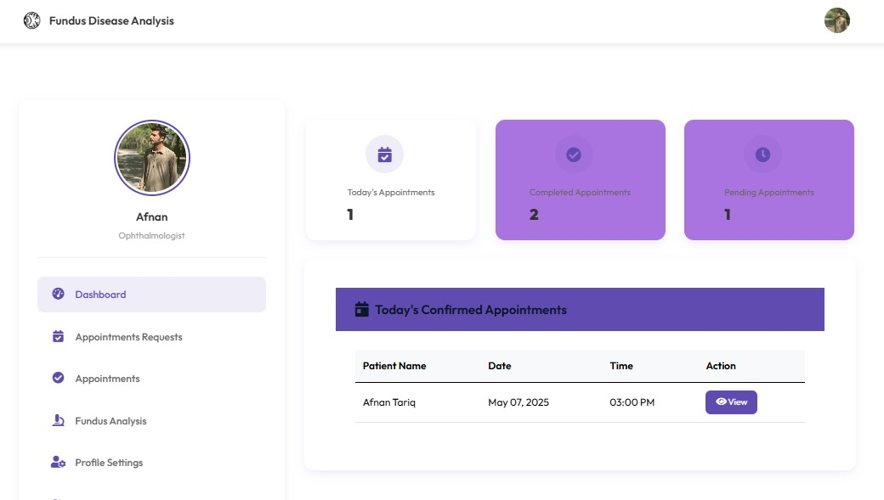

The "Doctor Dashboard" on the Doctors page of the Retina Fundus Analysis platform provides specialists with an overview of appointments, patient reports, and notifications. It enables doctors to manage schedules, review AI-generated diagnosis reports, and communicate with patients efficiently.